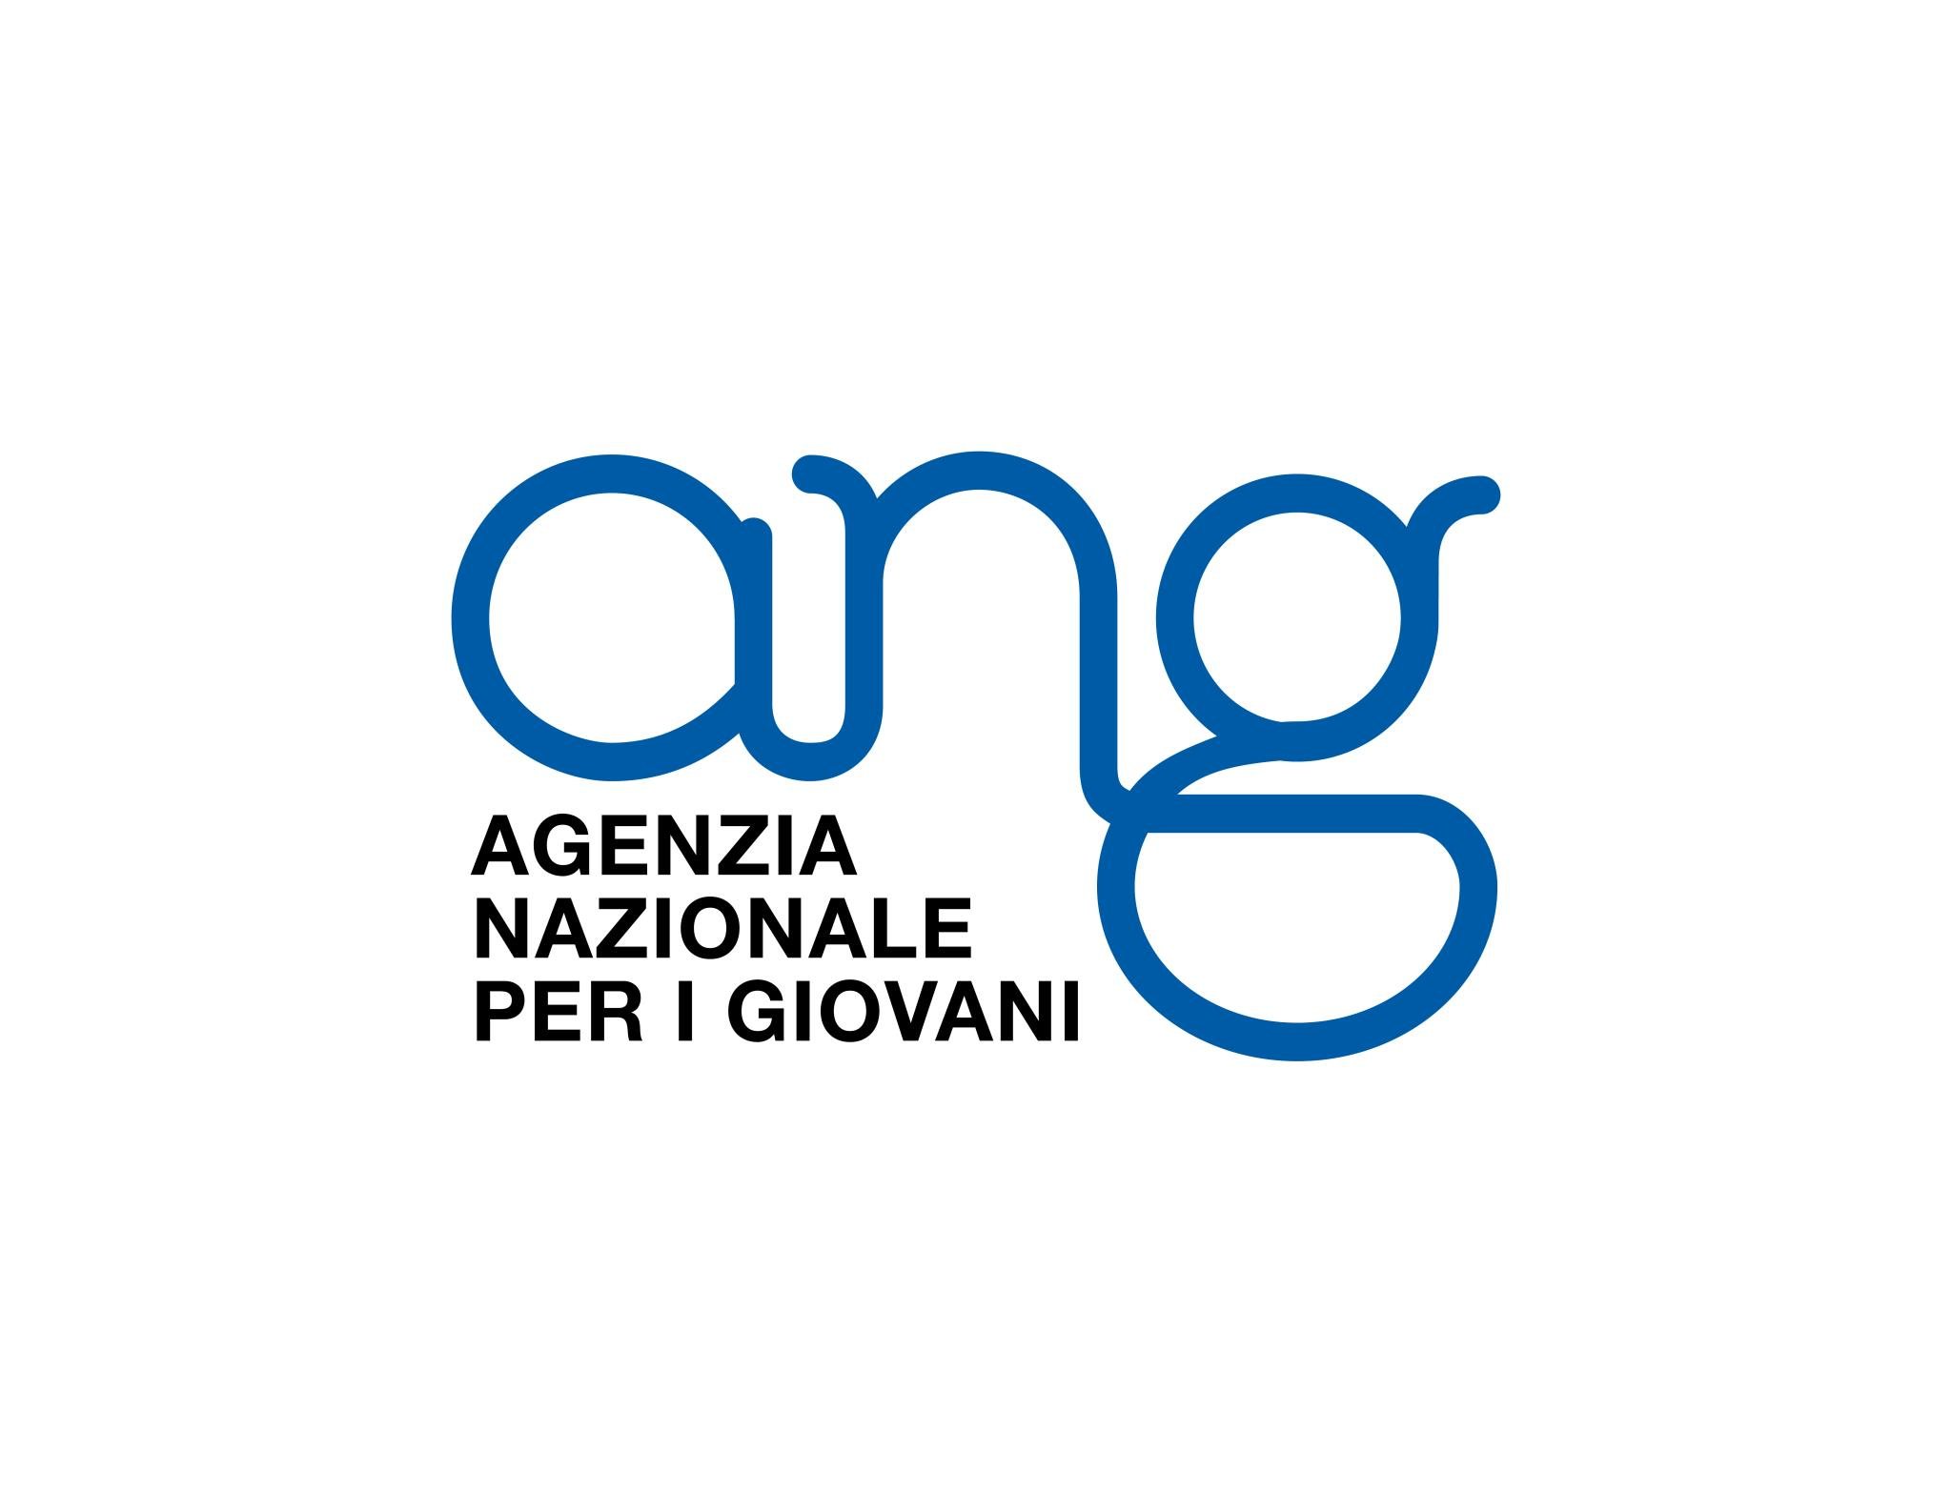
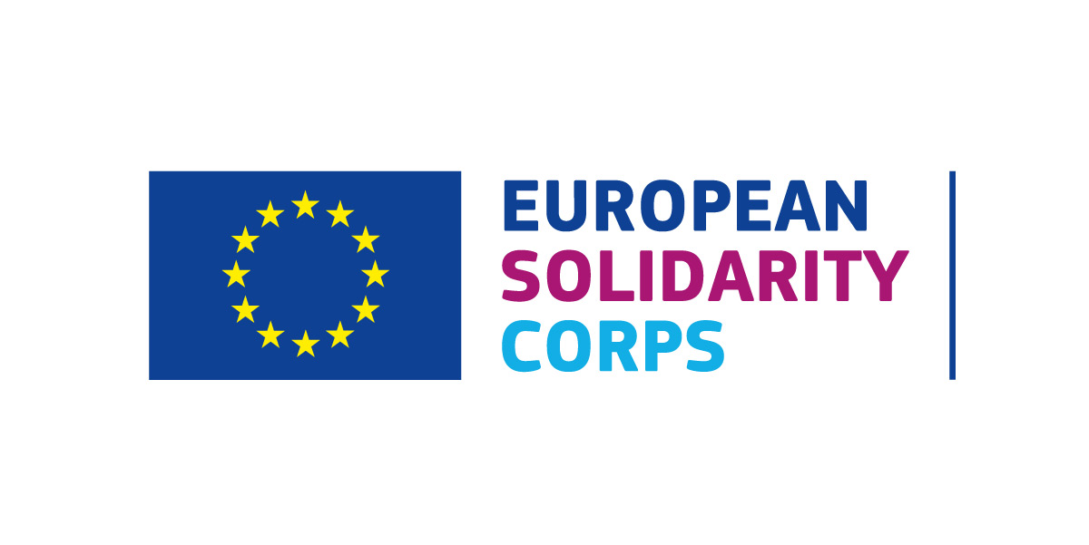
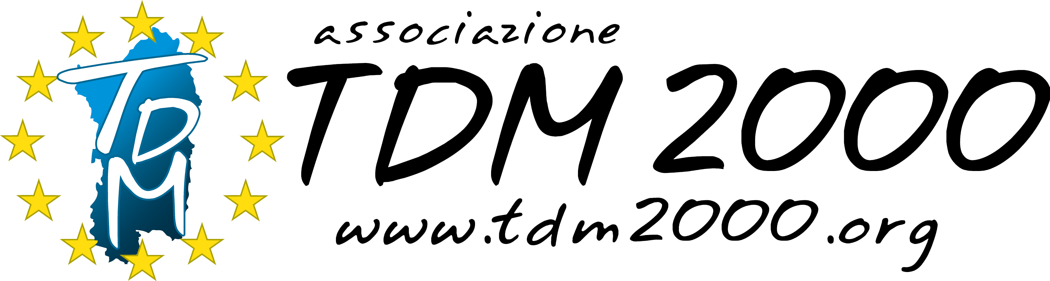

European solidarity corps project :

LIVE: Learning through International Volunteering Experiences

Hosting organization : TDM 2000
Venue: Cagliari, Italy
Duration: 7 months
Dates: 01/04/2021 – 1/11/2021

Summary:

With the project LIVE, the volunteers will be the protagonists of a process aimed at emphasizing and enhancing not only solidarity, the core value of the program, but also and above all tolerance, human rights and the need for inclusion and comparison with different realities and continuous interaction as a means to break down prejudices, racisms and violence. In addition, young volunteers, with their presence in the hosting and sending territories, and thanks to the media channels that will be used throughout the project, will witness first-hand the focus values of the project, as well as inspiration for young people by promoting volunteering and international youth mobility as a tool for social and individual empowerment. The objectives of the project are: - Promote social inclusion and the fight against racism and the promotion of volunteering as an instrument of active citizenship - Support the involvement of young people in educational paths on the importance of active participation; - Promote cooperation between young people, making them aware of their role as protagonists in building a multicultural and inclusive Europe; - Disseminating European opportunities and programs as an international mobility tool essential for intercultural learning and to encourage active participation. - Provide young people with the tools necessary to consciously take on the role of citizens of a community and European citizens, so that they can feel at the same time less distant from European institutions and can fully enjoy the opportunities built for them thanks to public contributions.
The 4 volunteers coming from Russia, Latvia, Serbia and Portugal will implement 2 activities over 7 months in Cagliari, Italy hosted by TDM 2000 no profit organization: "365 Volunteering" and "Human Rights 4ALL"; the first aimed at promoting 12 stories of local and international volunteering experiences that will be presented both online and through radio podcasts, the second aimed at making short videos on the Universal Declaration of Human Rights and on the European Charter of Fundamental Rights of the Union Europe dedicated to the very young. In addition, volunteers will be involved in promoting international programs in which they participate and raising awareness about active participation in host communities.

Activity n° 1

The "365 Volunteering" activity will focus on the collection, arrangement and publication of volunteer stories, carried out by people living in Sardinia and who have carried out volunteering with the European Commission Programs (long / short term EVS, ESC volunteering or solidarity) or volunteering in Italian programs such as Civil Service National / Universal or in small regional and local programs / initiatives. This activity aims to spread the values ​​of volunteering and solidarity in favor of one's own or different community. The two volunteers involved will support the local activity managers in the different phases / tasks of implementation
1) promotion of the idea through social channels, local media and in the network of local associations active in EVS and ESC, Volunteer Service Center, Volunteer Representation of Civil Service.
2) creation of a contact form to collect proposals for stories
3) collection and study of proposals and contact of potential protagonists (12 stories + bonus)
4) meeting and collection of stories / interviews + photos
5) creation of the final version of the story
6) inclusion of stories in the online platform
7) graphic creation and layout in calendar format for 2021
8) broadcasting chosen stories on UNICA radio (University of Cagliari) which was recently included in the Local Regional channels of the Ang Inradio Network
9) promotion of the online platform through media, social networks etc.
10) creation of local events for the presentation of the calendar and its distribution
11) uploading of the materials created on Salto and on E + Result platform
12) dissemination of the access links to the materials of point 11

In addition to their specific activity and related tasks, the volunteers will be involved in project promotion and dissemination of results, taking care of the Instagram and FB profile called "100volunteersdays" (www.instagram.com/100volunteersdays) which tells the TDM 2000 volunteers and their path of growth and learning. In addition, on a regular basis they will write posts about their volunteering experience which will be published in the TDM 2000 international mobility blog (volunteeringineurope.blogspot.com).

Activity n° 2

Human Rights 4ALL is dedicated to the creation of a digital platform based on the Universal Declaration of Human Rights and on the Charter of Fundamental Rights of the Union European Union (CDFUE). Volunteers will support the creation of a series of videos that will be chosen by the local youth (through an internet vote). The videos will be present not only on Youtube channels but also on the TikTok platform, very popular among teenagers. This activity aims to further disseminate the knowledge of the fundamental rights of each citizen, both those sanctioned by the United Nations and by the European Union, as an instrument not only of awareness of one's rights but above all as a

form of respect for those of others, written and guaranteed so that inclusive and supportive communities can grow. Dissemination by means closer to young people is increasingly necessary so that they are not only rights recognized on paper but translatable into daily actions and episodes.
The two volunteers involved will support local activity managers in the different stages / tasks of implementation:
1) reading and understanding the proposed texts (Universal Declaration of Human Rights and CDFUE)
2) drafting of the text and rules for online voting and related publication
3) promotion of online voting through websites, social media, media, etc.
4) collection of voting results
5) plot writing for the realization of mini videos for Tiktok and Youtube
6) video production (shooting and editing)
7) uploading videos to digital platforms
8) promotion of video channels and uploaded videos (sites, social media, Unica Radio, etc.)
9) promotion of videos in the association's events locally
10) uploading of the materials created on Salto and on E + Result platform
11) dissemination of access links to the materials of point 11

In addition to their specific activity and related tasks, the volunteers will be involved in project promotion and dissemination of results, taking care of the Instagram and FB profile called "100volunteersdays" (www.instagram.com/100volunteersdays) which tells the TDM 2000 volunteers and their path of growth and learning. In addition, on a regular basis they will write posts about their volunteering experience which will be published in the TDM 2000 international mobility blog (volunteeringineurope.blogspot.com).

